CPE301 – SPRING 2019

Design Assignment 4a

Student Name: Do Le

Student #: 2001183621

Student Email: led2@unlv.nevada.edu

Primary Github address: <https://github.com/DoVietLe>

Directory: <https://github.com/DoVietLe/assignments>

The goal of the assignment is to develop the above code to do the following:

1. Write an AVR C program to control the speed of the DC Motor using a potentiometer connected to PC0. Use an interrupt on a button (PC1/2/3) to stop and start the motor at each click. The minimum speed of the motor should be 0 when pot is at minimum position and at maximum position should be 95% of PWM value.

1. **COMPONENTS LIST AND CONNECTION BLOCK DIAGRAM w/ PINS**

Components

• XPlained Mini Board

* ATmega328PB
* Programmer

• Atmel Studio 7.0

* Compiler

• TB6612FNG Motor Driver

• DC Motor

• Potentiometer

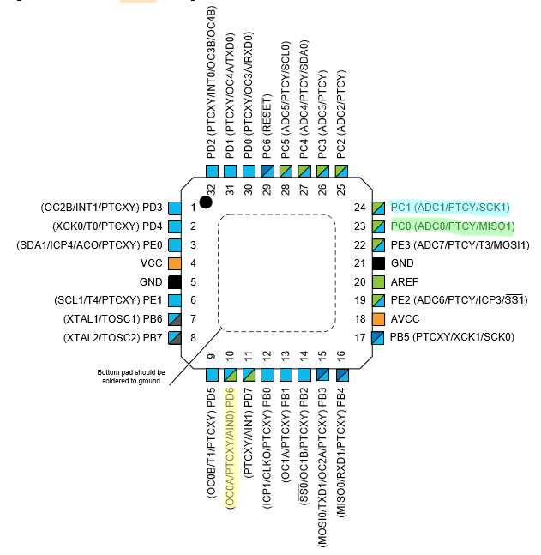• Pushbutton

Figure : Pinout

Block Diagram

PWM used on PD6 to control motor.

Pin change interrupt used on PC1 to receive button input.

ADC used on PC0 to read potentiometer value.

1. **INITIAL/MODIFIED/DEVELOPED CODE OF TASK 1/A**

C Code

#include <avr/io.h>

#include <avr/interrupt.h>

#define MAX_PWM 255

volatile *uint8_t* status = 0x00; // Keeps track of whether the motor is on.

void enableADC() {

// Sets PINC0 as input.

DDRC &= ~(1<<PINC0);

// Sets up ADC settings.

ADMUX = 0x40; // Reads from ADC0. Right justified. Internal 1.1V reference.

ADCSRB = 0x00; // Free running mode.

ADCSRA = 0b10000111; // Enables ADC with 128 pre-scaler.

}

void disableADC() {

ADCSRA &= 0x7F; // Disables the ADEN bit.

}

float analogRead() {

ADCSRA |= (1<<6); // Enables ADSC to start AD conversion.

while (!(ADCSRA&(1<<4))); // Waits until ADIF is set indicating ADC is done.

ADCSRA |= (1<<4); // Clears ADIF flag.

return ADC; // Returns value.

}

void setDuty(float duty) {

OCR0A = (duty/100)*MAX_PWM;

}

void setPinInterrupts() {

DDRC &= ~(1<<PINC1); // Sets PINC1 as input.

PCICR = (1<<PCIE1); // Enables pin change interrupt on PCINT[14:8].

PCMSK1 = (1<<PCINT9); // Enables pin change interrupt on PCINT9 (PINC1).

sei(); // Enables global interrupts.

}

int main(void) {

// Stores the duty cycle.

int dutyCycle = 0;

// Sets up everything.

enableADC();

setPinInterrupts();

// Constantly updates the duty cycle.

while (1) {

// Gets duty cycle based on potentiometer.

dutyCycle = 95*(analogRead()/1023); // Max duty cycle is 95%, so calculate ratio of 95% potentiometer is on.

setDuty(dutyCycle); // Set the new duty cycle to the PWM.

}

}

ISR(PCINT1_vect) {

// Makes sure a rising edge occurred on button press.

if (PINC & (1<<PINC1)) {

status = ~status;

if (status) {

DDRD |= (1<<PIND6); // Uses PIND6 as output for OC0A.

TCCR0A = 0b10000011; // Use Fast PWM on OC0A in non-inverting mode.

TCCR0B = 0b00000010; // Use Fast PWM with 1024 prescaler.

} else {

DDRD &= ~(1<<PIND6); // Turns PIND6 into an input pin.

TCCR0A = 0x00; // Turns off PWM.

TCCR0B = 0x00; // Turns off clock.

}

}

PCIFR = (1<<PCIF1); // Clears interrupt flag.

}

1. **DEVELOPED MODIFIED CODE OF TASK 2/A from TASK 1/A**

No modified code.

1. 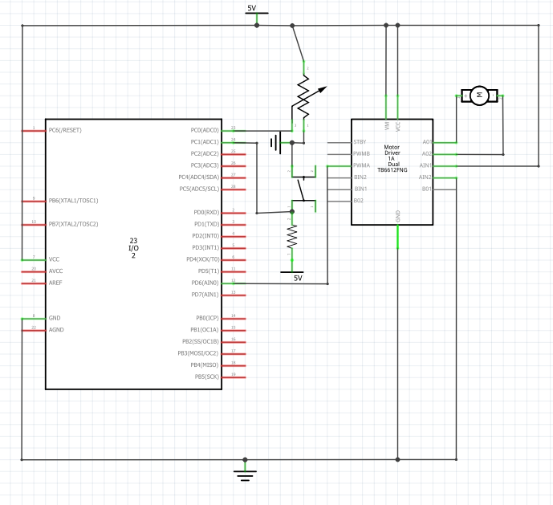**SCHEMATICS**

Figure : Setup schematic

1. **SCREENSHOTS OF EACH TASK OUTPUT (ATMEL STUDIO OUTPUT)**

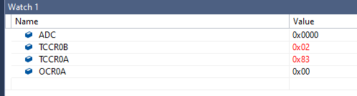

Figure : PWM timer settings

1. **SCREENSHOT OF EACH DEMO (BOARD SETUP)**

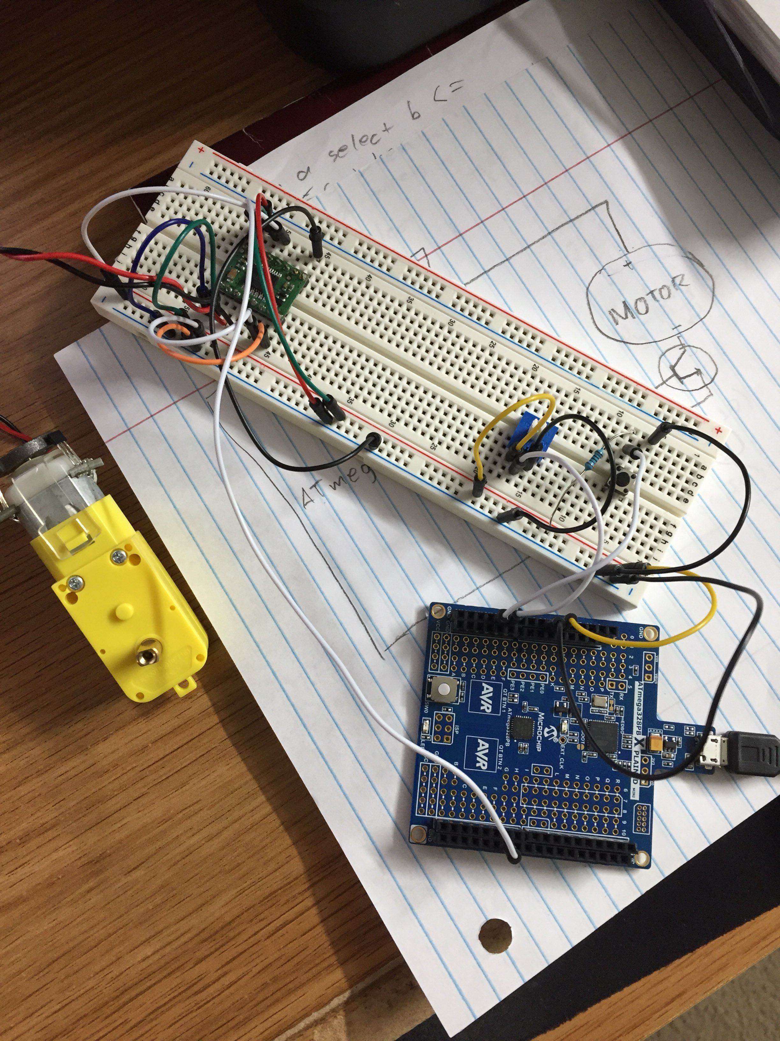

Figure : Breadboard setup

1. **VIDEO LINKS OF EACH DEMO**

Task 1

https://www.youtube.com/watch?v=_1Qgvis60jg

1. **GITHUB LINK OF THIS DA**

https://github.com/DoVietLe/assignments/tree/master/ESD301/LAB04a

**Student Academic Misconduct Policy**

<http://studentconduct.unlv.edu/misconduct/policy.html>

“This assignment submission is my own, original work”.

Do V. Le